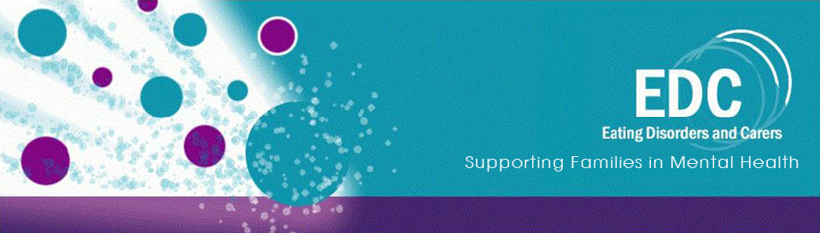
CO-DEPENDENCY - 1 DAY FAMILY CARERS’ WORKSHOP
with
Veronica Kamerling - Experienced Carer & Trainer
Sonia Parsons - Experienced Carer
Henrietta Wood - In Recovery From Bulimia & Compulsive Overeating
(Henrietta Wood Is Veronica Kamerling's Daughter)

FRIDAY 13th SEPTEMBER 2019
Registration: 9.30am Start: 10.00am Finish: 4.00pm
Venue: The Fitzrovia Room, Park Crescent Conference Centre,
International Students House, 229 Great Portland Street London, W1W 5PN
(Opp. Great Portland Street tube station and near Regents Park tube station)

Cost: £70.00 per person.
The word co-dependency can sometimes be difficult to understand and it often appears as though blame is attached to how families are caring for their loved ones. This workshop aims to show the positive impact on family relationships when co-dependency is addressed and where no blame or feelings of guilt are attached. We hope to provide a safe and confidential space for Carers to meet other Carers and to share their various experiences
Subjects to be covered:
- The meaning of co-dependency
- Henrietta's personal experience of having a co-dependent relationship with her mother
- How to address co-dependent issues within the family either current or in the future - specific practical examples
- Motivational interviewing and reflective listening techniques
- Role Play (optional participation)
Contact details: Veronica Kamerling T:01252 444954 M 07733 260475 E:veronica@talktalkbusiness.net

